Table of Content

1 Introduction 2

2 Problem 2

3 Method 3

3.1 Scoping 3

3.1.1 Context 3

3.1.2 Function 3

3.1.3 Life's Principles 4

3.2 Discovering 4

3.2.1 Function Lens 4

3.2.2 Operating Conditions 6

3.2.3 Naturalist Lens 7

3.3 Creating 9

3.4 Evaluating 10

3.4.1 Evolve to Survive 10

3.4.2 Be Resource (Material and Energy) Efficient 10

3.4.3 Adapt to changing conditions 11

3.4.4 Use Life-friendly Chemistry 11

3.5 Translating 12

3.5.1 Concept overview 12

3.5.2 Vision and data gathering 14

3.5.3 Aerial motility 14

3.5.4 Air-to-water transition 15

3.5.5 Underwater motility 16

3.5.6 Structural design 17

3.5.7 Defense mechanism 17

4 Cradle to Cradle 18

5 Discussion 18

6 Conclusion 19

7 References 19

# Introduction

Micro air vehicles are booming in the past decades. MAVs gained use in a wide range of purposes and are available for industrial, public, and private use. Branches that profit of MAVs are surveillance, photographing, and delivery of goods. Fast developing markets are good indicators for potential. Therefore, is developing an innovation for this specific market connected with minor risk. In Collaboration with the Swiss army, the goal is to develop a Prototype MAV that can be deployed for both air as well as water missions. The conceptual phase of the prototyping follows biomimicry methods. Biomimicry methods are created for technical solutions which implement the advantages of nature's evolution and adaptability.

# Problem

Bionic engineering principles are difficult to integrate in the construction of a MAV. To enhance the performance of technological systems, bionic engineering incorporates biological principles and materials. This can be a complex and subtle procedure, requiring an in-depth knowledge of both the biological systems being replicated and the technological requirements of the MAV.

MAVs would be able to function in a greater variety of situations if they could transition from water to air. MAVs with the ability to transition from water to air, for instance, might be utilized for search and rescue operations in places containing bodies of water, such as flood zones or coastal regions. Additionally, MAVs with this capability could be utilized for aquatic research and monitoring, including the study of marine life and water quality monitoring. Overall, the capacity to move from water to air would significantly increase the potential uses and applications of MAVs, making them even more important tools for a variety of sectors and organizations.

Multiple variables contribute to the difficulties of incorporating bionic engineering principles into the design of an MAV. The necessity to balance the opposing demands of performance, functionality, and durability is one of the key obstacles. Due of the fragility and environmental sensitivity of bionic materials and systems, it might be challenging to fit them into an MAV's tough and high-performance design. In addition, the integration of bionic systems into an MAV necessitates a high level of technical skill and complex production procedures, which can be time-consuming and costly.

Implementing bionic engineering principles in the design of an MAV necessitates a cautious and nuanced approach, and it is a substantial task that calls for a combination of technical expertise, ingenuity, and resourcefulness.

# Method

## Scoping

Scoping is used to clarify the Requirements. Main parts of scoping are defining the boundaries, challenge, context, and constraints of the Project. The Scoping Process is applied to the project according to the biomimicry modelling wheel (Fig. 1). The model divides the scoping efforts into three main categories:

* Context definition
* Function identification
* Life's principle integration

### Context

Project boundaries define the space for development. Each work step has to full fill the projects requirements in the assigned boundaries. The Boundaries for the development of the MAV-prototype has been set around the product itself. All functions are focused on the MAV and the interaction with its surroundings. Communication with the pilot must be implemented. The control unit for the pilot is not part of the project.

Developing a MAV-prototype according to the challenge requires the prototype to perform in air and water. These requirements lead to the context of the project. Separating the context into air, transition and water helps to focus on relevant influences. Movement in air exposes the MAV to weather, topology, and hazards. Weather includes the influences of sunlight, Temperature, humidity, rain, wind, ice, and snow. Hazardous objects can be animals, insects, moving objects, obstacles, abrasives, and people. The topology of Switzerland is a combination of mountains, forests, glaciers, buildings, or whole cities. Transitioning between the two main context fields challenges the MAV with change of fluid density, water surface tension and floating objects on water. During the movement in water, resist and adapt to water condition, topology and hazards is vital for the MAV to persist. Water condition is containing the properties of sweet water, current and waves. Topology includes the differentiation of lakes and rivers, depth, stones, and water plants.

### Function

Combining the three context modules helps to define the necessary functions for an MAV to fit the requirements of the challenge (Fig.2). Ein Bild, das Text enthält.

### Life's Principles

When looking at how to integrate/use natural engineering solution, following Life's Principles have been identified to integrate them into the project:

* Adapt to changing conditions
* Change between air and water
* Temperature change
* Altitude change
* Be resource efficient
* Navigation for over and underwater

## Discovering

Understanding the technical answers that the natural world must give after millions of years of natural evolution is the focus of the discovering phase.

The goal was to identify relevant biological models or solutions for the challenges and functions that the MAV would have to overcome/perform. Therefore, using the terms of our scoping section, we began to seek inspiration in nature. We conducted a keyword search on Asknature.org for some of the tasks identified during scoping. Other elements were derived from experience. In the section that follows, only the few mechanisms that made it into the final prototype are listed.

### Function Lens

In this method, we searched multiple sources for the functionalities our challenge must satisfy. Consequently, the questions/functions were required to be Biologized.

#### How would nature transition from air to water?

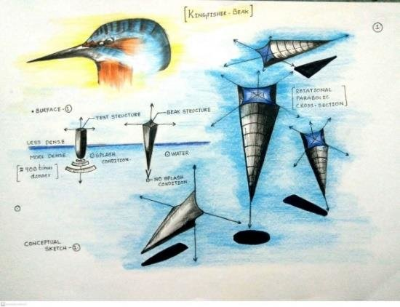The transition between air/flight and water/diving is one of the most vital and crucial capabilities that the MAV must master to perfection.

Figure 1: shape of a kingfisher's hydrodynamic beak

The issue is surface tension, which increases with speed and causes the water to become solid like concrete. By researching the internet for "transitioning air/water" it turned out that various bird species have already developed this trait over many years. One of these species is the Kingfisher. They fly approximately 30 meters above the ocean and dive into it at a speed of 97 kilometers per hour. Not only can they dive to depths of up to 25 meters, but they can also hunt fish as deep as 90 meters. To break the water tension optimally, they fold their wings right before impact, and the anatomy of their beak's aids in this process. Thanks to the narrow cone and it's fine point entering the water can be made gradually and with little resistance. The length of the beak is important. A shorter, rounder beak would increase the angle and have a worse resistance.

#### How would nature navigate underwater?

Figure 2: Beluga whale using underwater echolocation

Without navigation, the MAV is ineffective. The issue lies in finding an underwater navigation system and having a backup plan.

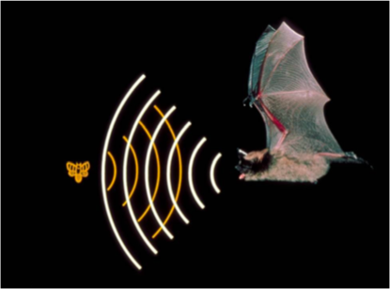Various creatures, such as the tenrec, bats, and whales, utilize a well-known variant of this called the echosounder. This method involves releasing extremely high-pitched noises that reflect off things and return to the animal. You may determine the distance, direction, speed, density, and size of an object based on the duration of bounce and the incoming waves.

Figure 3: Bat using echolocation

#### How would nature tackle underwater and airborne communication?

Fortunately, or thanks to intelligent evolution, animals also use ultrasound to communicate. The same approach applies here as mentioned previously.

#### How does nature solve airborne and underwater motility?

MAVs use traditional designs for flight that may not be as agile and versatile as required for our machine's functions and missions. Therefore, we looked for inspiration from the natural world and the ways it solves airborne motility for a more effective and appropriate solution.

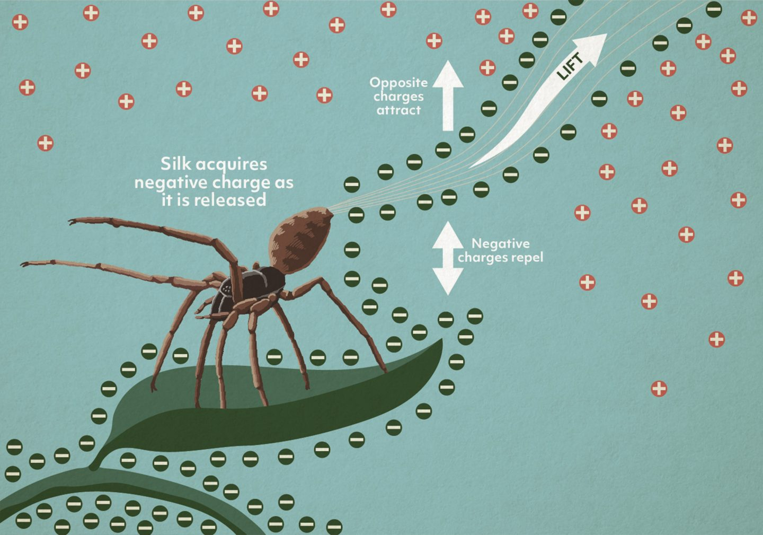For example, certain spider species can be found flying several kilometers in the air and traveling over a thousand kilometers out to sea. They can even detect electrically charged atmospheres and use their senses and environment to their advantage. To accomplish these feats, they crawl along a negatively charged edge and then shoot out strands of silk, which pick up the negative charges of the surface and repel away from it, allowing them to fly.

Figure 4: spider using silk and electric current to become airborne

Due to the rapid entry of our MAV into the water, the underwater movement strategy emphasized direction changes and short distances. As such, we looked for underwater motility strategies in nature, and Flagella from certain bacteria and microorganisms came to our mind.

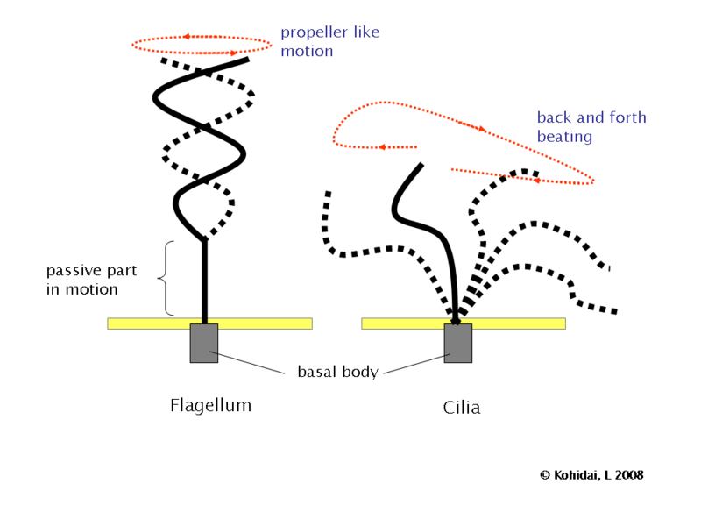Numerous microorganisms utilize flagella, which are long, whip-like appendages, to travel through water. They are made of proteins known as flagellins, which are spirally organized around a central core. At the base of the flagellum lies a molecular motor called the basal body that powers the flagellum. The rotation of the basal body causes the flagellum to oscillate, propelling the bacterium through the water. The microbe can control the movement's direction and velocity by regulating the rotation of its basal body. Flagella are an integral aspect of the biology and behavior of numerous aquatic bacteria, as they are particularly effective at propelling microbes through water.

Figure 5:flagellum concept of operation

### Operating Conditions

The MAV must always consider the operating conditions. It is necessary to consider a wide variety of application domains, which is especially important when thinking about the varied topography of Switzerland.

#### Resilience to big temperature variation

Variations in temperature can pose a serious threat to electronics. Large temperature swings can pose several issues for electronic components, including thermal expansion, which can put physical stress on the components, and changes in the electrical properties of materials, which can compromise the performance and dependability of the electronics. In addition, elevated temperatures can hasten the deterioration of materials and the aging of components, leading to their early failure. Extremely low temperatures, on the other hand, can lead to issues such as brittle failure, higher resistance, and decreased performance. In order to maintain the dependability and performance of electronic devices, it is necessary to safeguard them against significant temperature fluctuations.

Therefore, proper thermal insulation is necessary for the normal operation of the MAV. To address this issue, we can assess the tactics utilized by various animals and plants to withstand extreme temperatures.

A nice model is a furry animal, such as a beaver.

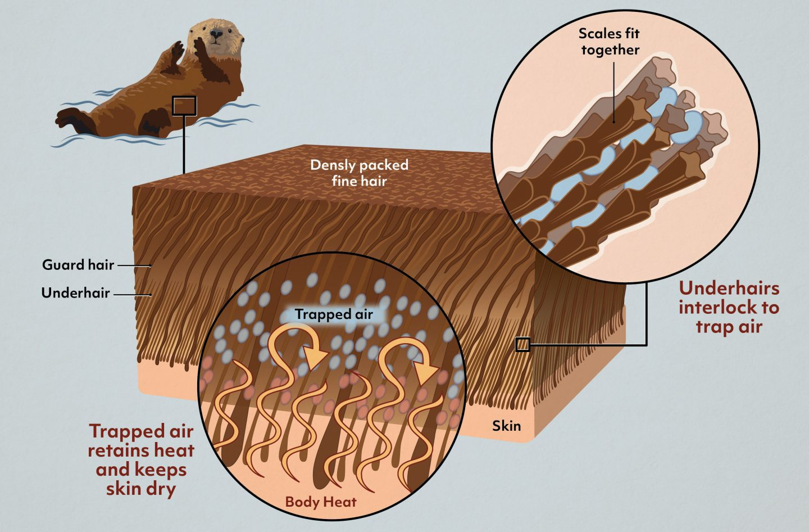Animal fur always consists of two unique types of hair strand. The longer ones are called guard hairs and act as a protective covering for the underhairs, which are denser (one guard hair protects on average 3 underhairs).

Figure 6: typical insulation layer of fur of an otter

Beavers and other aquatic mammals have scales on the outermost layer of their underhair. This causes the hairs to intertwine, preventing cold water from penetrating and trapping air bubbles. Air bubbles effectively insulate a surface.

Extremophile multicellular creatures, such as the Pompeii worm (*Alvinella Pompejana*), are similarly well adapted to great temperature changes. The measurements revealed that they can survive despite a 60°C differential between two bodily sections. It accomplishes this by constructing protective tubes that generate a mosaic of microenvironments from which the researcher may determine the thermal and chemical gradients.

#### Structural Integrity

Structural design is crucial for ensuring the structural integrity of a system or structure.

As such, it is essential to consider durability as a distinct criterion, as the MAV must be able to tolerate water pressure, water impact, and the possibility of collision. Nature is once more a fantastic source of inspiration for structural integrity, with a wide variety of techniques available to meet the criteria.

Ein Bild, das Text enthält.
As an example of shock absorption, a woodpecker must absorb force while pecking at a tree to prevent brain harm. This is made possible by the anatomy of its cranium. The layered, plate-like structure of the skull bone resembles a sponge. They serve as shock absorbers by deflecting impact forces in various directions.

Figure 7: Bone structure

Diatoms are another example of extraordinary biological engineering. These organisms have developed a distinctive strategy for preserving structural stability and rigidity while limiting the amount of energy and construction materials required to construct their outer silica shell.

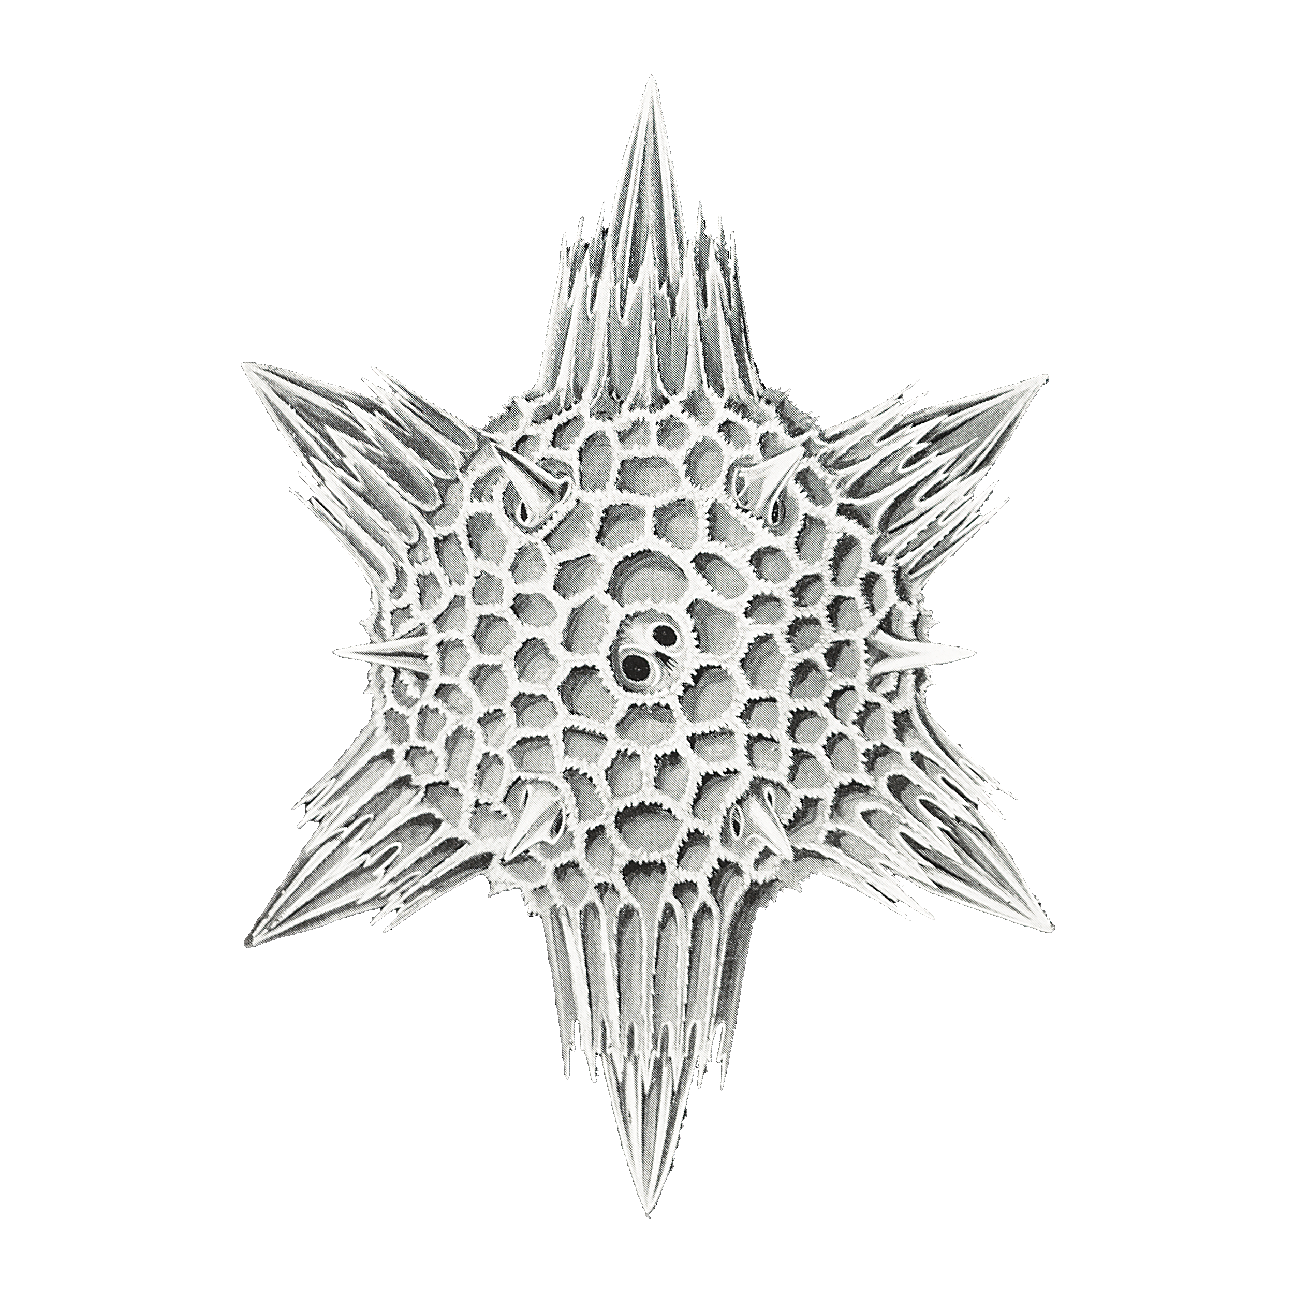They acquire a very high level of structural stability through a specific shape, such as circular or star-shaped, and a pore pattern. Besides diatoms The Venus' flower basket marine sponge features a distinctive structure in addition to diatoms. Sea sponges, like diatoms, are comprised of silica (glass).

Figure 8:Naturalist drawing of a Diatomea

A coating of silica spheres between 50 and 200 nanometers in diameter and organic compounds can limit the spread of fractures. The relatively rigid inorganic spheres and the energy-absorbing organic compounds are arranged in a square lattice formed of tubes. This is the most prevalent sort of glass sponge, and it is so tough that the shrimp residing in its glass basket cannot escape.

### Naturalist Lens

Turning the tables and drawing ideas from nature are the next logical step after conducting a functional analysis and determining the operational circumstances. Websites such as [**Asknature.org**](https://www.asknature.org)can be leveraged for this purpose to look for new and original ideas.

#### Buoyancy

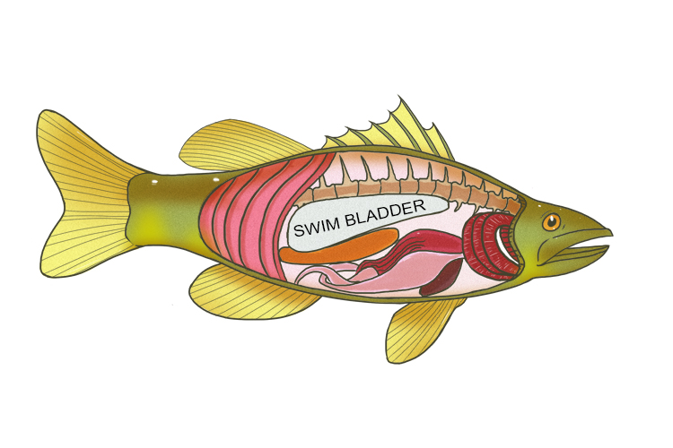To create neutral or positive buoyancy, fish use a simple but very solid strategy. They have a swim bladder, which is in the body cavity. This bubble is filled with gas, which can provide buoyancy due to its lower density.

Figure 9: swim bladders in a fish

#### Swarm behavior

Swarm behaviors can be useful for MAV systems because they allow multiple drones to coordinate and work together to achieve a common goal.

Swarm behavior includes collision detection and avoidance of the separate "units" that comprise it. For example, locusts travel in a massive swarm without clashing. Their motions, like those of humans, are translated into electrical signals by the eye and then read by the brain. The fascinating part is that locusts only notice movements that disrupt their flight path. This occurs because when an object moves directly towards them, the electrical signal rises. This signal is then filtered based on its strength so that only objects on a direct flight path are recognized.

Collaboration among the many members of the swarm would be another useful aspect. Honeybees can communicate their expertise in two ways. On the one hand, they communicate through movement by performing a "waggle dance," which conveys to other bees, for example, the location of a food source. They can, however, communicate using pheromones. When a worker bee stings, pheromones are released, alerting other bees to the danger.

#### Hydrophobic coating

Hydrophobic coatings are advantageous because they prevent water from clinging to a surface, hence reducing drag, enhancing the performance of aquatic vehicles, and providing corrosion protection. These coatings can be placed intentionally to a surface, or they can arise naturally, as with lily pads. Lily pads feature a hydrophobic layer that repels water, allowing them to float on the surface of ponds and other bodies of water. This coating is created by the cells on the surface of the lily pad, which exude a layer of hydrophobic wax. The wax provides a barrier that keeps water from adhering to the pad, allowing it to float and travel through the water without difficulty. The natural occurrence of hydrophobic coatings in lily pads and other plants provides inspiration for the creation of artificial hydrophobic coatings for a variety of practical uses.

#### Defense mechanism

Underwater and in the air, a MA3V is never alone. Therefore, not only to protect themselves from animals, but also specifically to protect themselves from enemies, a protection mechanism must be developed. The requirements for this mechanism are that it does not compromise the functionality and slimness of the MAV.

One option would be to use the eels as a model. They can discharge between 400 - 600 volts in surges through the tail. This causes its prey to be stunned.

There are many other defense mechanisms such as the ink cloud of an ink fish, bright colors for deterrence, or spines of a cactus.

It was decided to use a neurotoxin coating inspired by the most poisonous bird in the world, the Hooded Pitohui. In its skin and feathers are various poisons, which is derived by its diet. The toxin causes numbness and burning and is a simple and elegant defense option.

## Creating

After the phase of discovery, it was possible to move on to the subsequent phase, which comprised a variety of exciting natural techniques. This chapter explains which concepts are combined to build a prototype, how they interact, and which biomimicry techniques are inapplicable.

1. To make transitioning from air to water as easy as possible, two different traits inspired by plunging birds will be adopted. On the one hand, attention will be paid to a slender hydrodynamic design, which helps to break into the water at high speed, and on the other hand, the wings and propellers will be collapsible to further optimize the hydrodynamics.
2. For vision, we are integrating the bee's functions by incorporating compound vision cameras that can perceive as many aspects of the environment as possible. Not only the vision but also the swarm behavior should work as well as the bees. This will be made possible by artificial intelligence with emergent behavior, which replicates the behavior of bees so that multiple MAVs can work together.
3. As a defense mechanism, the prototype will be covered with a non-lethal toxin to keep enemies in the environment and human opponents at bay.
4. To navigate underwater and in poor conditions, echolocation technology is used for maximum performance in all conditions.
5. Inspired by whales and bats, ultrasound is also used to communicate and transfer research data underwater.
6. To create a hydrophobic effect, the surface of the fabric is coated with a water-repellent coating, which also increases bacterial resistance.
7. The drone's frame is modeled like marine organisms such as Sponges and Diatomea. Topological optimization, a novel technique, guarantees a lightweight but sturdy construction with insulation capabilities that shield delicate gear from impacts.
8. Like the Anacondas in the Amazonian Basin or certain microorganisms with their flagellum, while underwater the drone should be propelled by its tail. Thus, it can push itself and travel in 3D underwater space when agitated.
9. To control the buoyancy, a bladder similar to the fish should be used. This bladder should be filled with gas and be controllable to stabilize the drone in the water.

Of course, many exciting technologies did not qualify for the final prototype such as:

* "Surfing on electric fields" was not feasible as a means of transport because the weight of the MAV is too great.
* Although the Pompeii worm is insanely resistant to temperature differences, its protective tube building strategy did not translate well into a micro air vehicle.
* Fur, as insulation, has long been discussed as it can also be water repellent and hydrophobic. However, it was decided against, as a coating and a smooth surface is more practical and easier to produce.

In the discussion, the possibility of moving forward under water for short distances was also often discussed, as the use case was only intended for a fast, deep dive. It was decided to incorporate a biomimicry aspect for a controlled forward movement under water. Therefore, the discovery process had to be gone through again and the flagella was found.

## Evaluating

The Evaluation chapter aims to objectively assess and compare the performance of selected functions based on the principles of Life. This thorough analysis will provide valuable insights into the efficiency and effectiveness of each function and help inform future decision-making and design choices. The results of this evaluation will be used to determine the best course of action for optimizing and improving the overall system.

### Evolve to Survive

Continually incorporate and embody information to ensure enduring performance.

#### Replicated Strategies that work

Functioning micro air vehicles have already implemented many strategies. therefore, some components such as the propeller structure and RF (Radio Frequency) communication will be adopted in the new design. In addition, various strategies from nature mentioned in the Idea Creation chapter are reused and adapted to the MAV context.

### Be Resource (Material and Energy) Efficient

Skillfully and conservatively take advantage of resources and opportunities.

#### Use Multi-functional Design

Several designs with several functions have been merged. One of these is the flagella, which functions both a mode of transportation in water and an antenna for RF waves in the air. The echo sounder is a similar device that can be used not only for navigation but also for communication. The topologically optimized surface is the final and most fascinating multifunctional design element, since it combines optimal lightness, insulation, and resistance.

#### Recycle all Materials

The use of recyclable materials, such as BiomeHTX, for 3D printing our MAV structure is highly advantageous as it allows for the creation of a modular design. This not only simplifies the manufacturing process, but also aligns with our cradle-to-cradle design philosophy, which seeks to minimize waste and maximize resource efficiency. Using recyclable materials in the 3D printing process not only reduces our environmental impact, but also allows us to create a more sustainable and resilient product.

#### Fit form to function

The adaptation of form to function while utilizing biomimicry designs enables the development of a lean solution design that successfully satisfies the needs of the product or system. By researching and replicating natural designs efficient and effective solutions with low environmental impact can be identified. This minimalist approach reduces not only the quantity of resources needed to make the product, but also waste and environmental impact. By harmonizing form and function in this way, sustainable and resilient designs can be built.

### Adapt to changing conditions

Appropriately respond to dynamic contexts.

#### Redundancy through diversity

We placed a significant emphasis on variety in the creation of our system, especially for crucial components like navigation and communication. To account for probable failures, fluctuations in visibility, and the unexpected nature of settings, we used both cameras and echolocation for navigation. Furthermore, we used two separate communication technologies, RF and echolocation, because how it works in water differs greatly from how it works on land. We hoped to ensure the dependability and durability of these critical components by using this varied approach.

### Use Life-friendly Chemistry

Use chemistry that supports life processes.

The adoption of life-friendly chemistry presented a challenge, since the hydrophobic and non-toxic coating we intended to utilize is a chemical product that necessitates in-depth analysis. While several viable solutions exist, additional research is required to ensure their safety in all authorized application regions. To limit harmful effects on living organisms, it is crucial to ensure the use of non-lethal and environmentally friendly chemicals. Therefore, we must evaluate and confirm the suitability of these options.

## Translating

### Concept overview

The MA3V (Micro Aero-Amphibious Autonomous Vehicle) is intended to be a flexible and efficient instrument for mapping, surveillance, reconnaissance, and rescue operations in a range of conditions. It is perfect for use in the field because of its simple design and low maintenance requirements, and it is extremely effective for a variety of tasks due to its extensive capabilities.

MA3V mockup design
MA3V units are meant to operate in swarms, with at least three units collaborating to execute their missions. These machines employ enhanced compound vision and active sonar for obstacle avoidance, underwater navigation and communicate over secure channels.

Figure 10: MA3V

As an underwater drone, the MA3V makes use of ingenious natural adaptations for effective movement in aquatic conditions. By contracting its wings and propellers and adopting a vertical position, it can descend to depths five times its size due to its hydrodynamic design. It then uses flagella-like propellers and sonar technology to move and map its surroundings, while its compound camera eyesight enables it to successfully orient and navigate. To improve its hydrodynamic qualities, the MA3V's surface is nano-etched with a hydrophobic pattern that mimics the structure of lotus leaves.

The MA3V is coated with a mild neurotoxin, comparable to that secreted by hooded pitohui birds to prevent unauthorized handling. This poison numbs an attacker's senses and induces a burning sensation that can persist for hours.

The MA3V is constructed utilizing 3D printing techniques, with the topology optimized to maximize its strength and resiliency while decreasing material prices, production time, and weight. The MA3V is a unique and efficient solution for a variety of underwater and airborne operations.Diagram

Figure : Mav internal mockup

### Vision and data gathering

The MA3V uses two main methods for data gathering: compound vision and sonar.

The employment of numerous cameras and sensors on an MAV drone for machine vision, pathfinding, obstacle avoidance, and data collection, known as compound vision, has several advantages. For starters, it increases the drone's capacity to navigate in complicated situations and its general durability. Second, it enables improved data collecting and processing by integrating different perspectives and sensor readings for a more thorough picture of the environment. However, compound vision has several disadvantages. One significant downside is the increased expense and complexity of the system due to the integration and calibration of various cameras and sensors. Moreover, greater processing requirements can result in slower response times and worse battery life. Furthermore, the data provided by several sensors may be very voluminous, necessitating the need of significant processing resources to process.

When utilized for communication in both the air and the sea, sonar, or sound navigation and ranging, has various advantages. Firstly, it enables communication in places where other modes of communication, such as radio waves, may be unable to penetrate, such as deep water or caves. Secondly, because it requires less power, it has a longer battery life and can be utilized for stealth communication and is less detectable. There are, however, significant disadvantages to employing sonar for communication. One significant downside is that it is highly directed, thus obstructions such as rocks or ship hulls can quickly block or diminish the signal. Moreover, environmental noise can interfere with the signal, making it difficult to identify the intended message from background noise.

Sonar is a great instrument for echolocation and topography because it detects objects and characteristics in the surroundings. It can detect and locate things in the surroundings as well as map the shape and composition of the seafloor or underwater structures. However, sonar has a poorer resolution than other imaging technologies such as lidar or cameras.

### Aerial motility

The MA3V is a single propeller, winged drone with V-shaped tail rudder.

They have several advantages over other types of drones.

***Pros:***

* **Increased flight duration:** Winged drones have a much greater flight duration than quadcopters or other multirotor drones, due to their efficient aerodynamic shape and the ability to glide.
* **Higher speed and range:** Winged drones can fly at much higher speeds and cover greater distances than multirotor drones, making them well-suited for long-distance surveillance or mapping missions.
* **Greater payload capacity:** Winged drones can carry larger payloads than multirotor drones, allowing them to carry heavier cameras or other equipment.
* **Better stability in wind:** Winged drones can fly in windy conditions than multirotor drones, thanks to their aerodynamic shape and ability to fly in a straight line.

***Cons:***

* **Less maneuverability:** Winged drones are not as maneuverable as multirotor drones, making them less suitable for close-range inspections or other missions requiring precise control.
* **More difficult to control:** Winged drones can be more difficult to control than multirotor drones, especially for inexperienced pilots.
* **More complex to launch and land:** Winged drones require a runway or other launch and landing surface, making them less suitable for takeoff and landing in confined spaces or rough terrain.
* **Higher maintenance costs:** Winged drones require more maintenance than multirotor drones, due to the complexity of their mechanical and electronic systems.

To alleviate the challenges associated with winged drone launch and landing, the MA3V can be launched in a folded-wing position, allowing it to conduct a V-Tol maneuver until a target altitude is reached, at which point it deploys its wing and transitions to a winged drone mode.

This would enable operators to deploy and retrieve the MA3V in more confined spaces.

Also, concerning maintenance costs, since the design leverages cradle-to-cradle design methodology, the MA3V is made of modular parts that can easily be replaced/modified if necessary.

### Air-to-water transition

If the MA3V needs to transition from air to water, it will first slow down over the intended body of water, then transition into a diving position by folding its wings against its body while maintaining altitude with its rotors.

Once the drone is vertical and at the appropriate height, it disables its rotor and folds its rotor blades, allowing the MA3V to do a ballistic dive into the water.

It can easily breach the water's surface because to its hydrodynamic body shape and hydrophobic exterior.

### Underwater motility

While underwater, the MA3V relies on two system to navigate: its flagella and its water bladders.

Underwater drones typically use artificial water bladders, also known as buoyancy control devices, to manage their buoyancy. These solutions allow the drone to alter its buoyancy and maintain a desired depth by filling or emptying the bladder with water.

***Pros:***

* **Allows for precise depth control:** Artificial water bladders enable underwater drones to maintain a precise depth, which is important for tasks such as scientific research or inspection of underwater structures.
* **Can be adjusted in real-time:** The buoyancy can be adjusted in real-time, which allows the drone to adapt to changing conditions.
* **Energy efficient:** Using water bladder to control buoyancy is energy efficient as compared to other methods such as adjusting propeller thrusts.

***Cons:***

* **Limited capacity**: The capacity of the water bladder is limited, which can make it difficult for the drone to ascend or descend quickly or to maintain a steady depth in strong currents.
* **Extra weight:** The water bladder adds extra weight to the drone, which can affect its performance and maneuverability.
* **Extra maintenance**: The water bladder requires regular maintenance and can be a point of failure, which can be critical when the drone is in remote location.
* **Additional complexity:** the addition of water bladder increases the complexity of the system, which can make it more difficult to operate and repair.

A flagellum-like propeller, often referred to as a biomimetic propeller, is a form of propeller that imitates the structure and action of a flagellum, a long, whip-like appendage found on certain bacteria. This propeller design is being studied for use in underwater propulsion because it has the potential to be more efficient and agile than conventional propellers. In the MA3V's case, while airborn, the flagellum doubles as an RF-antenna for communication.

***Pros:***

* **Greater efficiency:** Flagellum-like propellers are designed to mirror the natural movement of microorganisms, resulting in greater efficiency and less energy consumption than conventional propellers.
* **Greater maneuverability:** The flexible and undulating structure of propellers resembling flagella can improve maneuverability, allowing for greater control and precision in underwater navigation.
* **Reduced noise:** The biomimetic design of flagellum-like propellers can result in reduced noise, making them a better choice for covert operation or sensitive areas like coral reefs.

***Cons:***

Designing and producing propellers resembling flagellums can be difficult and complex, requiring advanced materials and production procedures.

* **costly:** flagellum-shaped propellers can be expensive.
* **Limited knowledge:** There is still a lack of understanding of the fundamental principles of flagellum-like propulsion, making it challenging to optimize the design and performance of these propellers.
* **Durability:** The flexible structure of flagellum-like propellers may make them more susceptible to wear and tear than conventional propellers, making them less durable.

### Structural design

The exterior is fashioned in the form of a water droplet. Its long, slim body aids in both aero/hydrodynamics and water breaching.

The entire body has been topologically tuned internally. This increases the overall structure's strength-to-weight ratio by eliminating unneeded weight. It also creates extra space for batteries, electronics, etc. inside the drone.

The entire structure is easily replaceable and/or modifiable via 3D printing. For instance, if a mission requires a white structure for the drone since it will be operating in snowy conditions, simply print another white structure.

### Defense mechanism

MA3V drones are equipped with both passive and active protection methods to safeguard their sensitive information and data if they are lost or seized. The first passive approach adopted is the coating of the drone's surface with a non-lethal poison. When this coating is touched with bare hands, it quickly dulls the senses and provides a burning feeling. The active protection system is activated simultaneously. The drone's AI system determines that it has been lost or captured when it senses that it has deviated from its designated program. As a result, a message is sent to other MA3V drones instructing them to avoid its last known location, and all data contained on the drone is wiped clean, rendering it useless for the adversary.

The drone operator would be the one applying the poisonous coating before each flight, since the poison degrades overtime, and it would handle the whole system with appropriate protection gears like gloves.

# Cradle to Cradle

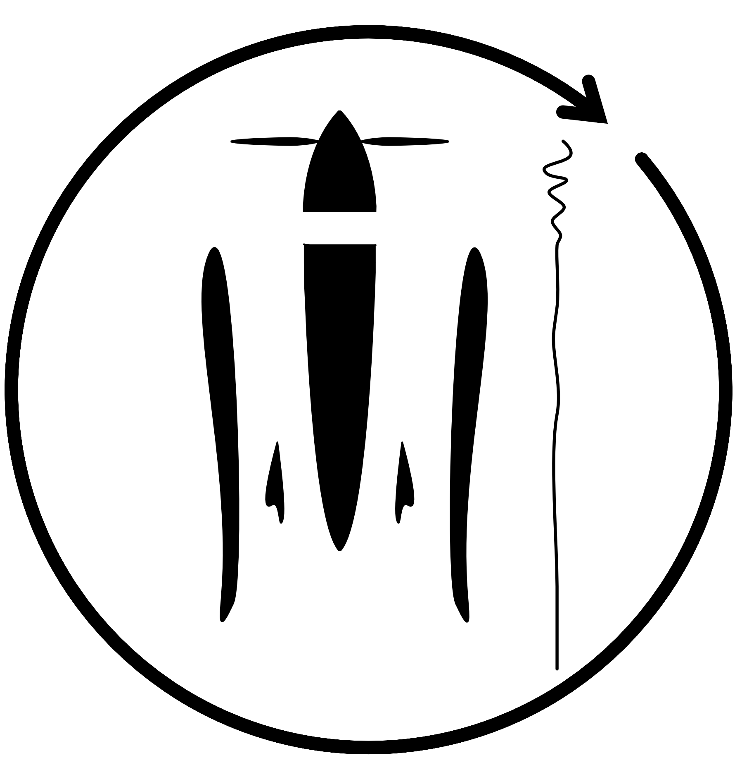Innovation through biomimicry, applied life's principles, and all other methods is insufficient without achieving zero waste production and building a cradle-to-cradle product. To accomplish this, various ways were worked out so that the changes on zero waste can become as high as possible.

Figure 12: Cradle-to-Cradle diagram for the MA3V

1. The hull, propeller, and topologically optimized structure will be made from a 3D-printable biodegradable material, BiomeHTX. This is not only useful because lost parts are ecologically degradable but also efficient in the prototyping phase because 3D printing is simple and allows for easier iterations and testing.
2. A modular design is intended to extend the service life of an MAV. This is achieved by simply replacing or upgrading old or damaged components.
3. The electronics, which are not biodegradable, are encapsulated centrally. This results in no harmful chemicals leaking into the environment and makes it easier to extract the rare earths and electronics so that they can be given a new life cycle.

With a government-funded development partner and the strict detailed requirements in mind, it will be difficult to offer a MAV as a Service business model, as the drones carry critical information. Nevertheless, a return policy is targeted, in which the customer should bring back a used or defective part so that it can be optimally reused in the value chain. In addition, a maintenance service and flight lessons are offered to maximize the lifetime of the MA3V.

# Discussion

Using a cradle-to-cradle and biomimicry approach, the problem was addressed in an entirely different manner and viewed from an entirely different angle. This resulted in a complete rethinking of the functionality, with not just the question of what? but also the question of why? in constant focus. Beginning with the definition of the project's scope, it was unclear how the final output may appear, and everything that might be noteworthy was simply questioned and recorded. During the process of defining the scope and context, it became evident that the transition from the surface to the water is vital. During the discovery phase, numerous exciting and unique strategies were discovered that could (not always) be implemented; nonetheless, even if they were not implemented, they were kept in mind for the future project (e.g. sending data like water strides). After the more creative phase, it was determined whether the collected biomimicry approaches are compatible with and meet all cradle to cradle and life's principles requirements. This was not always simple to comprehend, as a great deal of experience is required for such an evaluation, but via extensive Internet study, much could be proven. When it came to the prototype, a substantial amount of preparatory work had already been performed; all that remained was to validate compatibility and technological requirements. This was not always straightforward, but time might be saved with careful preparation.

# Conclusion

The objective of this study is to create a multi-environment aerial-aquatic vehicle (MA3V) that can operate in both air and water using an ecological and nature-inspired approach. The concept has reached a point where minimum additional development is required prior to the fabrication of a first prototype, as a result of comprehensive investigation. Therefore, it is proposed to study further the following issues:

• What energy source is required for the operation of the MA3V?

• What choices for data storage are available?

• How is it possible to implement a transport function?

• In what prospective application areas might the Drone be utilized?

In conjunction with the Swiss Armed Forces, the prototype will be created and assessed for usefulness, durability, and efficiency following the production of a 3D model and the resolution of the aforementioned questions. Subsequently, any enhancements and lessons learned will be integrated into the subsequent prototyping iteration.

# References